**Writeup – John the Rocker**

**Step 1:** Convert the given id_rsa file to hash file. (use the ssh2john.py for the same)

**Command:** pyhton3 ssh2john.py id_rsa.idrsa.docx > hash

**Step 2:** Use **john the ripper** to find the flag from hash file. (Use rockyou.txt as wordlist)

**Command**: john -w=(Path of rockyou.txt) hash

**Process to follow:**

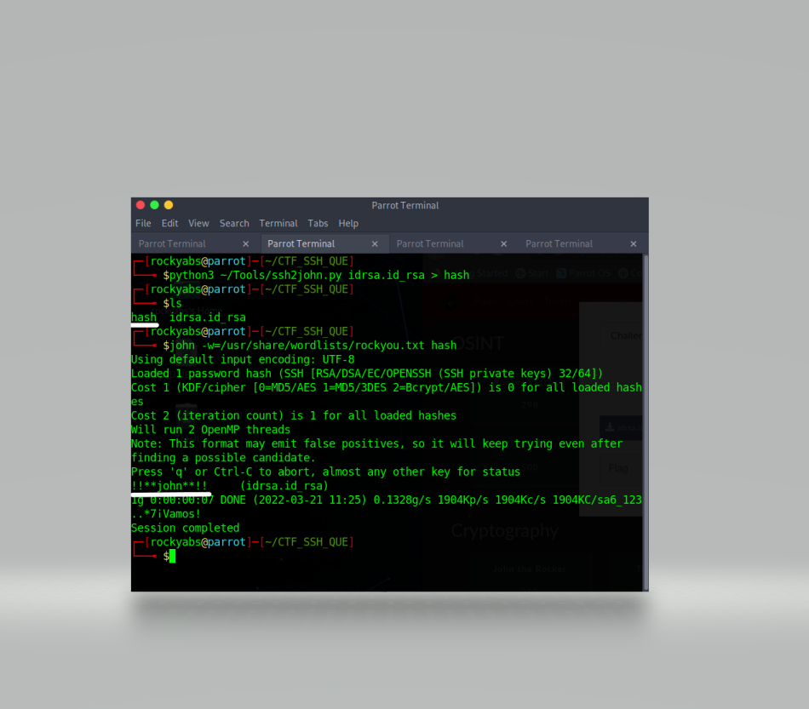

**Flag:** VishwaCTF{!!**john**!!}